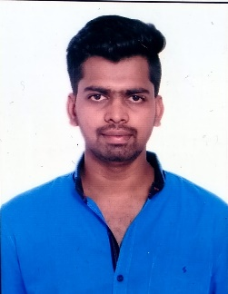 NAME : CHALLA GOWTHAM SAI

**Email :** [**gowthamsai1579@gmail.com**](mailto:gowthamsai1579@gmail.com) **Mobile no :** (+91)6303202452

# Career object :

To work in a professional organization that offers me a consistently positive and challenging atmosphere to learn new technologies and implement them for the betterment of business, also utilize the precise knowledge and strive for the career advancement.

# Educational qualification :

|  |  |  |  |  |
| --- | --- | --- | --- | --- |
| **S.No** | **Course** | **Year of study** | **College** | **Percentage% / Gpa** |
| **1** | B-Tech  (Civil Engineering) | (2019-2022) | Sri Vasavi Engineering College | 7.93 |
| **2** | Diploma (Civil Engineering)) | (2016-2019) | S.M.V.M Polytechnic College | 82% |
| **3** | S.S.C | (2015-2016) | Vignan High School | 8.5 |

**Technical Skills :**

* Java
* SQL
* HTML
* MS Excel
* MS Word

# Projects:

* Strength Enhancement of the soil subgrade by providing geosynthetic reinforcement Completed project about ground improvement techniques in my B-tech 8th semester in Vasavi engineering college

# Internships:

* I completed my internship in PRI sub division at Tadepalligudem as a supervisor for construction of roads and buildings under PRI Department for six months from 01/05/2018 to 31/08/2018. And secured 98% marks in that.

# 

# Accomplishments :

★ Won prizes in quiz, essay writing, debit competitions and in cricket tournaments in my secondary education.

★ Won 2nd prize in essay writing competition in diploma in S.M.V.M polytechnic college.

★ Won prizes in technical quiz and level hunting competitions conducted in vasavi engineering college

# Personality traits:

* + Positive attitude and Self-Motivated.
  + Excellent time management & ability to perform under pressure
  + Quick learner

# 

# Personal profile :

Father's name : Challa Nagaswara Rao

Date of birth : 15/07/2001

Hobbies : playing games , watching movies. Languages known : Telugu , English, Hindi Nationality : Indian

Address : D.No:7-157,near Kalavagattu, Badampudi, Badampudi,Ungutur mandal, Pin:534411 West Godavari dist , Andhra Pradesh.

# Declaration :

I declare that the above-mentioned details are all true & I bear the responsibility for any discrepancy.

**Signature** Ch.Gowtham Sai

**Place :Badampudi**